## ABSTRACT

Water usage across fast developing sub continental economies is growing at unprecedented rate which is more than twice the rate of the population growth for the past century. Although there is not yet a global water shortage, about 2.8 billion people, representing more than 40% of the world's population, live with some form of water scarcity off which almost 1.2 billion live under conditions of physical water scarcity, which occurs when more than 75% of the river flows are withdrawn in countries like India and China. Remaining 1.6 billion people live in areas of economic water scarcity, where human, institutional, and financial capital limits access to water, even though water is available locally to meet human demands. The project is an attempt to provide drinking water to the people where there is shortage of pure and fresh drinking water so that we can overcome the problem mentioned above.

The idea is to make use of the moisture present in air to produce water, because there is always certain percentage of humidity present in air even if we are in desert. Hence this would be a reliable technology. The method is to cool the air available in atmosphere which will convert the water from gaseous state i.e. from moisture into liquid. The system will work on solar energy by using solar cell hence it can be also use effectively in place where there is lack of electricity. The air to be cooled will be filtered first so we could deliver harmless water which makes our idea non-toxic and dependable. There is no need of long transmission lines since sunlight is present in almost all part of our country. Hence we can implement it at any place and this will also save the cost of transmission pipelines that we normally use for transmission of water. Hence the project aims to develop a technique of water production that can be practice by any one and at any place affordably and efficiently.

### TABLE OF CONTENTS

|  |  |  |  |  |
| --- | --- | --- | --- | --- |
| **ACKNOWLEDGEMENT** | | | | i |
| **DECLARATION** | | | | ii |
| **ABSTRACT** | | | | iii |
| **TABLE OF CONTENTS** | | | | iv |
| **LIST OF FIGURES** | | | | vi |
| **CHAPTER 1** | **Introduction** | | |  |
|  | 1.1 | Background | | 1 |
|  | 1.2 | Peltier effect | | 2 |
|  | 1.3 | Working features of Peltier | | 3 |
|  | 1.4 | Problem Identification | | 4 |
| **CHAPTER 2** | **Literature Survey** | | |  |
|  | 2.1 | Reviews of the papers | | 5 |
| **CHAPTER 3** | **Objectives and Methodology** | | |  |
|  | 3.1 | Objectives | | 10 |
|  | 3.2 | Methodology | | 10 |
| **CHAPTER 4** | **Study of atmospheric conditions** | | |  |
|  | 4.1 | Graphs showing temperature and humidity condition of Karwar | | 12 |
| **CHAPTER 5** | **Design and Components** | | |  |
|  | 5.1 | Design of the project | | 15 |
|  | 5.2 | Description of individual components | | 17 |
|  |  | 5.1.1 | Solar photovoltaic panels | 17 |
|  |  | 5.1.2 | Charge controller(PWM) | 18 |
|  |  | 5.1.3 | Battery | 19 |
|  |  | 5.1.4 | Heat sink | 19 |
|  |  | 5.1.5 | Brushless DC fan | 20 |
|  |  | 5.1.6 | Peltier | 20 |
|  |  | 5.1.7 | Switched mode power supply | 21 |
| **CHAPTER 6** | **Advantages, Disadvantages & Application** | | |  |
|  | 6.1 | Advantages | | 22 |
|  | 6.2 | Disadvantages | | 23 |
|  | 6.3 | Applications | | 23 |
| **Bill of material** | | | | 24 |
| **References** | | | | 25 |

**LIST OF FIGURES**

|  |  |  |
| --- | --- | --- |
| **FIGURE NO.** | **TITLE** | **Page No.** |
| 1.1 | Scarcity of water | 1 |
| 1.2 | Circuit diagram of Peltier | 2 |
| 1.4.1 | Graph of average humidity v/s months 2020 | 4 |
| 1.4.2 | Graph of average Temperature v/s months 2020 | 4 |
| 2.1.1 | Water extraction process | 5 |
| 2.1.2 | Peltier module | 6 |
| 2.1.3 | Conventional Atmospheric Water Generator | 7 |
| 2.1.4 | Block diagram of water generator | 8 |
| 4.1.1 | Temperature and humidity readings on 3rd September | 12 |
| 4.1.2 | Temperature and humidity on 3rd october | 13 |
| 4.1.3 | Temperature and humidity on 3rd November | 13 |
| 4.1.4 | Temperature and humidity on 3rd December | 14 |
| 5.1.1 | 3-dimensional view of assembly of the water extractor | 15 |
| 5.1.2 | 3 -dimensional view of peltier with heat sink | 15 |
| 5.1.3 | 2-dimensional view of water extractor | 16 |
| 5.1.4 | 2-dimensional view of peltier module with heat sink | 16 |
| 5.2 | Schematic diagram of the water extractor | 17 |
| 5.2.1 | Solar panel | 17 |
| 5.2.2 | Charge controller | 18 |
| 5.2.3 | 12v battery | 19 |
| 5.2.4 | Heat sink | 19 |
| 5.2.5 | Brushless DC Fan | 20 |
| 5.2.6 | Peltier module | 20 |
| 5.2.7 | Switched mode power supply (SMPS) | 21 |

**CHAPTER: 1**

## INTRODUCTION

Water is needed in all aspects of life. Difficult to purify, expensive to transport and impossible to substitute, Nearly 45 crore of people in 29 countries are staying in water- deficit regions. Nearly 70 % of the fresh water is used for irrigating the agricultural fields which has raised water conflict between the urban and rural areas If all this continues, then very soon i.e. by 2032, nearly half of the world’s population will be facing water shortage problem.

### 1.1 BACKGROUND

There is a saying, “water has only two aspects; when mixed with anything its NEED, and when not its LIFE”. Sometimes the terrible water scarcity in tropical countries like INDIA, Bangladesh, and African countries reminds us this quote immensely. The thermoelectric term manages the change of thermal energy into electrical energy and the other way around. When working in a cooling or warming mode the thermoelectric gadget is named a thermoelectric cooler (TEC).The point of the project is to make a versatile gadget using TEC that can be utilized to meet the drinking water prerequisites. The gadget will first consolidate water available in the air and after that purification unit can be introduced to this gadget for fresh drinking water reason.



Figure: 1.1: Scarcity of water

Atmosphere contains large amount of water in the form of vapor, moisture etc. Within those amounts almost 30% of water is wasted. The project is an attempt to make device that is capable of converting atmospheric moisture directly into usable and even drinking water.

The device uses the principle of latent heat to convert water vapor molecules into water droplets. Here, the goal is to obtain that specific temperature practically or experimentally to condense water with the help of some electronics devices. This project consists of a thermoelectric Peltier (TEC) couple, which is used to create the environment of water condensing temperature or dew point

### 1.2 PELTIER EFFECT

The peltier thermoelectric device has two sides (a p-type and an n-type semiconductor), and when DC current flows through the device, it brings heat from one side to other, so that one side gets cooler while the opposite one gets hotter. This is called Peltier effect and electron hole theory.

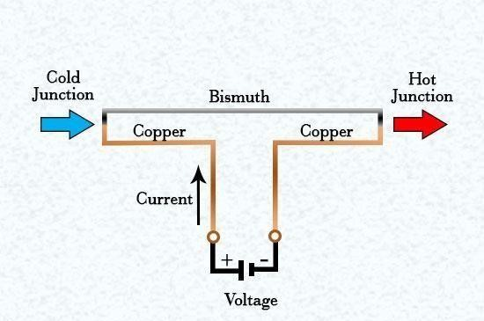

Figure 1.2: Circuit diagram of Peltier

A TEC also has some analogous parts. Energy (heat) is absorbed by

electrons at the cold junction, as they pass from a low energy level in the p-type semiconductor element, to a higher energy level in the n-type semiconductor element. It is the power supply that provides the energy to make those electrons to move through the system. At the hot junction, energy is expelled to a heat sink as electrons move from a high energy level element (n-type) to a lower energy level element (p-type).

Thermoelectric cooling utilizes the Peltier impact to make a heat flux between the intersections of two unique sorts of materials. At the point when DC voltage is connected to the module, the positive and negative charge bearers in the pellet cluster assimilate heat from one substrate surface and discharge it to the substrate at the inverse side.

**1.3 WORKING FEATURES OF PELTIER:**

For all intents and purposes TE couples are joined in a module, associated electrically in series and thermally in parallel to get a promising output. Be that as it may, it will be badly arranged to utilize such a gadget, to the point that has less beneficial work done to power proportion. There are modules accessible in the market as indicated by assortment of sizes, shapes, working voltages-currents and feature of heat pumping. The present pattern, be that as it may, is towards a bigger number of couples working at lower streams; before picking a proficient gadget, a few parameters must be resolved. These are:

TC: Temperature at Cold Surface.

TH: Temperature at Hot Surface.

QC: The heat to be assimilated at the Cold Surface.

Hot side temperature is associated with two noteworthy parameters:

1. The effectiveness of the gadget i.e. between the hot surface of the TEC and the ambient environment.
2. The temperature of surrounding condition into which the heat is being rejected.

The object to be cooled is attached with the frosty surface of TEC; accordingly the temperature of that object begins falling until it is as same as the temperature of the icy surface of the TEC.

Presently, ΔT can be characterized as:

ΔT = TH –TC

This contention ought to be precisely decided whether the plan is to work as wanted. For Example, we are considering few values to make it more understanding through graph Q =20 watt

TA = 35°C most extreme ambient air temperature

TC = 20°C required temperature of electronic part.

Before utilizing the graph to figure out which thermoelectric module is fitting for our application, we should first recognize the hot side temperature (TH) and the resultant temperature differential over the module (ΔT).

TH = TA + warm sink transcend surrounding = 25°C + 15°C = 50°C.

The temperature differential over the module can now be ascertained as follows:

ΔT = TH – TC

= 50°C – 20°C

= 30°C

### 1.4 PROBLEM IDENTIFICATION

* Since we had experienced a major drop in the availability of water in previous year,we thought of solving this problem of scarcity of water
* So to extract water from moist air we did an analysis of humidity and temperature at installation location
* The graphs shows the data of humidity and temperature of last year

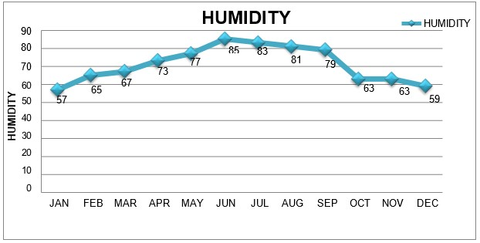

Figure 1.4.1: Graph of average humidity v/s months 2020

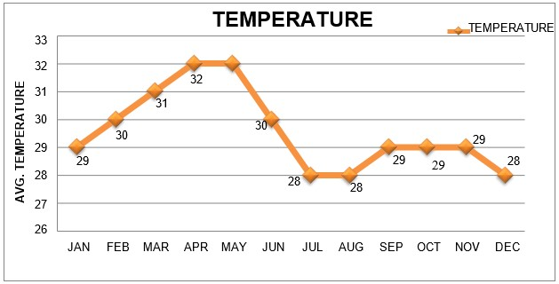

Fig 1.4.2: Graph of average Temperature v/s months 2020

## CHAPTER: 2

## LITERATURE SURVEY

We surmise that despite the fact that dehumidifying unit utilizing vapor pressure refrigeration framework is more powerful than the Peltier framework yet it needs as in it is not versatile and it produces a great deal of sound. And further more this framework is more costly. We watched that despite the fact that dehumidification by fluid desiccant technique is new and have a considerable measure of potential hypothetically yet when the scientists made a model and tried it the outcomes were not attractive. The gadget could deliver just 72.1 mL of water for every kW-hr. We acknowledge the way that dehumidification unit utilizing Peltier gadget is exceptionally convenient and condition amicable after reading the paper. It has straightforward plan and has high continuance capacity. Along these lines, this kind of Atmospheric Water Generator is the gadget which can be executed in extraordinary circumstances like amid surges or in abandon and rustic zones.

### 2.1 REVIEWS OF THE PAPERS

**Mrs.N.Deepa et.al [1]** this paper provides a method for extracting water from atmospheric air. Here they used vapor compression refrigeration cycle with the help of compressor. This paper provides the methodology of the refrigeration cycle for extracting water from air present in the surroundings. The methodology of the refrigeration cycle for extracting water from air present in the surroundings. The refrigeration method uses a compressor for increasing the pressure of the refrigerant and temperature of the refrigerant is constantly increased and the hot refrigerant passes through condenser coil and cools down its temperature. Then the refrigerant is passed through the capillary tube, where it changes its phase and cool down to extremely low temperature.

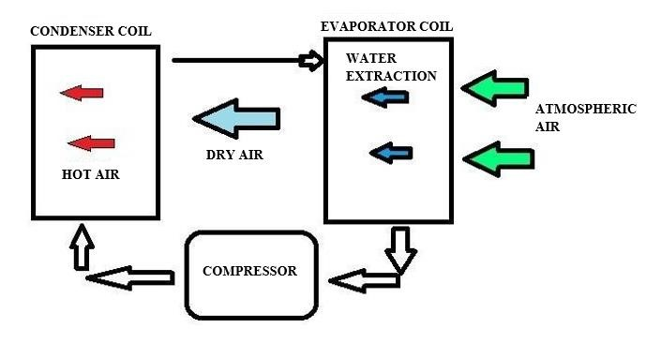

Figure 2.1.1: water extraction process

This low-temperature refrigerant is passed through the evaporator coil where it cools the surrounding and the refrigerant again flows through the compressor and cycle continues. Here we are setting up a fan system which passes constant air supply to the evaporator coil. Water present in air as humidity is extracted by bringing the air temperature below its dew point. A schematic fig is shown in figure 2.1.1. The water condenses from air and water is extracted. The compressor is provided with a temperature sensor controller which constantly monitors the temperature of the model and it switches off the compressor when reaches its freezing point. This prevents the formation of ice in the coil.

**Kiran Pawar et.al [2],** this paper suggests to generate fresh water from ambient air the surface should be cooled below dew point is required. The TEC array temperature is reduced below the dew point of ambient air with DC power supply. As the voltage goes on increasing the cold side temperature inversely goes on decreasing. The range of dew point temp in their location is from 2°C to 8°C to obtain such range of dew point the voltage is required from 3 volts to 8 volts. Air is forced to strike over module with input fan and droplets starts to form on the surface and falls on a gliding surface finally collected in a flask. The function of heat sink and fan is used to dissipate the heat and increase efficiency of condensation.

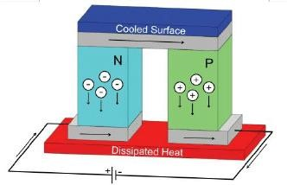

Fig 2.1.2: Peltier module

The Setup is composed of three major elements, thermoelectric cooled array of eight TEC12706 modules, photovoltaic solar panels, and heat sink and fan unit. The thermo-electric cooling Array is the main component in the experimental system and it is responsible for air cooling and dehumidification and fresh water generation. The cooling array is sized such that one side is cooled by thermo-electric modules and the other sides are assumed as well insulated. The thermo-electric cooling modules are powered directly by a DC electric power supply and play the role of heat pumps. Applying a voltage difference across the sides of the thermo-electric modules will result into a temperature gradient between the two sides of the module. As a result, the TEC modules will be extracting heat from the air flowing along the channel at the cold side of the thermo- electric cooling modules and rejecting this heat on the other side of the modules.

The PV solar panel is a renewable electrical power supply source, converting sunlight into electrical energy. Thus, the photovoltaic modules make an appropriate renewable solution for powering the thermo-electric modules with the sufficient electric power needed to pump the desired cooling capacity. It should be noted that the electrical energy produced by the photovoltaic modules varies considerably from one month to another, depending on the solar irradiation available and the ambient air conditions. In addition, no electrical inverter will be needed for the PV panels since the equipped thermo-electric cooling modules need a DC voltage power source to supply. Since the system extracts fresh water in humid climates.

**Ajinkya Taksale et.al [3],** this paper discussed about the extraction of water using MOFs (Metal Organic Frameworks). Metal Organic Frameworks are compounds consisting of metal ions coordinated to organic ligands to form up to 3dimensional structures. MOFs are able to be used as storage of gases such as hydrogen and carbon dioxide. In the morning, the chamber is closed, and sunlight falls on the solar absorber on top of the device which heats up the MOF, due to which it liberates the water droplets as vapor. The temperature difference, as well as the high humidity inside the chamber, causes the vapor to condense as liquid water, which drips into a collector.

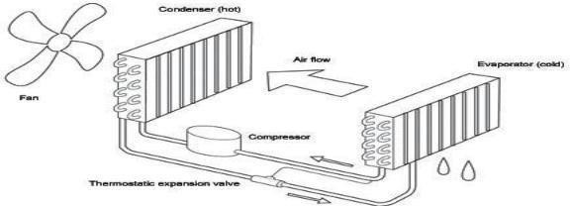

Fig.2.1.3: Conventional Atmospheric Water Generator

In a conventional AWG, a compressor circulates refrigerant through a condenser and then an evaporator coil which cools the air surrounding it. It leads to lowering the air temperature to its dew point, causing water to condense. A controlled-speed fan pushes filtered air over the coil. Then water is passed into a holding tank with purification and filtration system to help keep the water pure.

The water production rate depends on relative humidity, ambient air temperature and the size of the compressor. Atmospheric water generators become more effective as relative humidity and air temperature increase. The cooling condensation atmospheric water generators do not work efficiently when the temperature falls below 18.3°C (65°F) or the relative humidity drops below 30%.The principle of this type of AWG can be understood by the fact that water is often seen condensing and draining out from the home air conditioners when the ambient air is humid and hot. The economical AWG depends on the capacity of the machine, local humidity, temperature conditions and the cost to power the unit.

**Paul M. Cabacungan et.al4],** this paper says that the whole system can be divided into two major parts: Water Generation System and Water Treatment System. The water generator being optimized is made out of car air-conditioning parts and a dehumidifier to attain and sustain the condensation of atmospheric air vapor to liquid water. Water treatment system being the collected water will pass through a ceramic filter, and ultraviolet (UV) radiation for disinfection. This radiation can clean stored water for drinking.

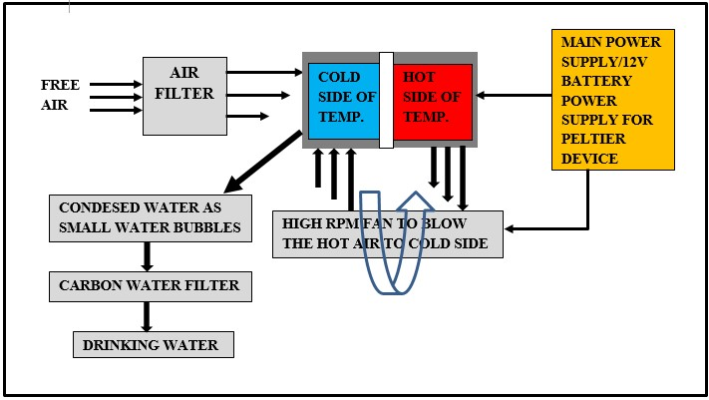

Fig 2.1.4: Block diagram of water generator

The assembled atmospheric water generator uses the same basic principles along with typical air conditioning units. The only difference is that all parameters must confirm to the needed requirements to attain and sustain the condensation of atmospheric air vapor to liquid water.

Before the low cost prototype, a first prototype was assembled using a refrigerator compressor, a car evaporator and condenser coils, copper tubes, capillary tubes, and a filter dryer. This set-up is yet to be optimized by enclosing it with an exhaust fan which should be strong enough to pull the air through the evaporator coil through the condensing coil and out from the unit.

In the case of the low cost prototype water generator, we initially got more than 18 liters of water when we injected an initial low pressure of 10 psi of the refrigerant and gradually increased it until the evaporator coil and condenser coil pressure gauges read 30-40 psi and 200-250 psi respectively. In this low refrigerant setting, we surpassed the dehumidifier rating of 15 liters a day. However, the power consumed of the latest prototype double.

## CHAPTER:3

## OBJECTIVES AND METHODOLOGY

### 3.1 OBJECTIVES

* To apply this system to a highly humid region, and extract as much condensed water for drinking purpose.
* Flexibility in Power Source - The plan ought to have the capacity to use an assortment of energy sources, including (however not restricted to) sun based, wind, and the customary power framework.
* To design a system in such a route such that it is a total power efficient solution and should extract water at low cost without creating much sound and vibration.
* To implement a type of Atmospheric Water Generator this can be quite useful in extreme situations like during floods or in desert and rural areas.
* To make a device which works like a renewable source of atmospheric water and doesn’t need a heavy power source.

### 3.2 METHODOLOGY

* As our project is wholly dependent on atmospheric condition, we have studied the temperature and humidity conditions so as to understand when we can extract maximum amount of water
* Methodology involves use of a thermoelectric peltier (TEC) couple, which is used to create the environment of water condensing temperature or dew point.
* The concept of this project can also be used as a better alternative in refrigeration science against conventional systems.
* The peltier thermoelectric device has two sides( a p-type and an n-type semiconductor), and when DC current flows through the device, it brings heat from one side to other, so that one side gets cooler while the opposite one gets hotter. This is called Peltier effect and electron hole theory.
* A conventional cooling system contains three fundamental parts-the evaporator, compressor and condenser. A TEC also has some analogous parts. Energy (heat) is absorbed by electrons at the cold junction, as they pass from a low energy level in the p- type semiconductor element, to a higher energy level in the n-type semiconductor element.

* It is the power supply that provides the energy to make those electrons to move through the system. At the hot junction, energy is expelled to a heat sink as electrons move from a high energy level element (n-type) to a lower energy level element (P type). Peltier coolers consist of a Peltier element and a powerful heat sink/fan combination.
* As soon as the device is powered the hot side starts getting hotter and cold side cooler; reaching the dew point temperature. The cold side of TEC starts to cool the air passing through its heat sink area and water vapors start to condense just like the water condensation happens outside a glass full of ice.
* Here two fans are used to take the moist air from the atmosphere and force it towards peltier module and another one fan is used as a exhaust to blow the used air back to the atmosphere.
* It is important to keep in mind that when TEC starts it takes a longer time to actually produce water, though it reaches the dew point temperature readily, but after some time the process acquires the speed to produce sufficient water according to the experiment result of this project.

**CHAPTER 4**

## STUDY OF ATMOSPHERIC CONDITIONS

The main aim of our project is to extract water from moist air by condensing the water vapor in the atmospheric air to extract water from moist air it is necessary to have favorable humidity and temperature condition. We studied the humidity and temperature changes along the day from September to December; these results are plotted in the graph given below. The humidity and temperature conditions are subjected to Karwar region only.

### 4.1 GRAPHS SHOWING TEMPERATURE AND HUMIDITY CONDITION OF KARWAR

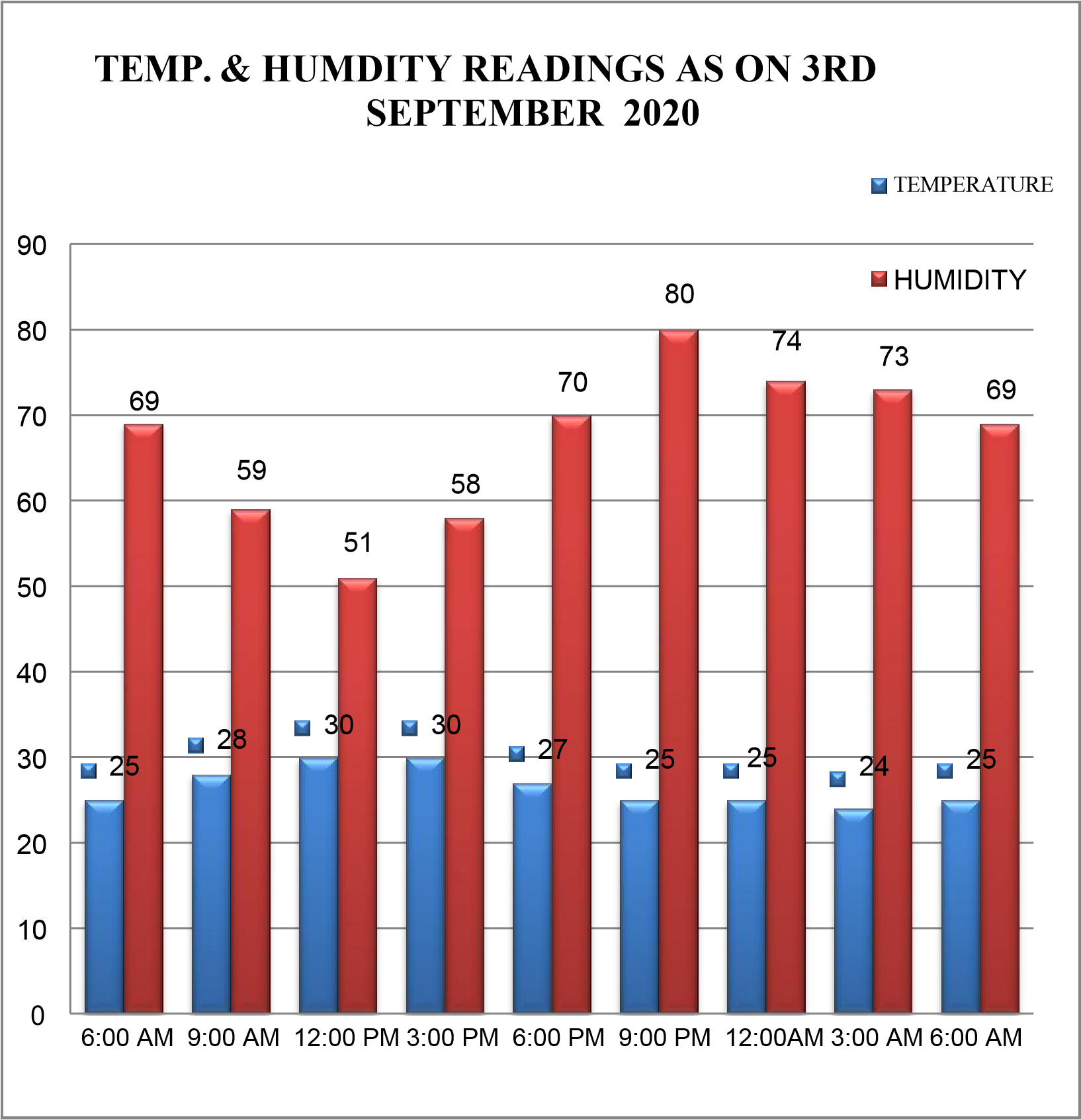

Figure 4.1.1: Temperature and humidity readings on 3rd September

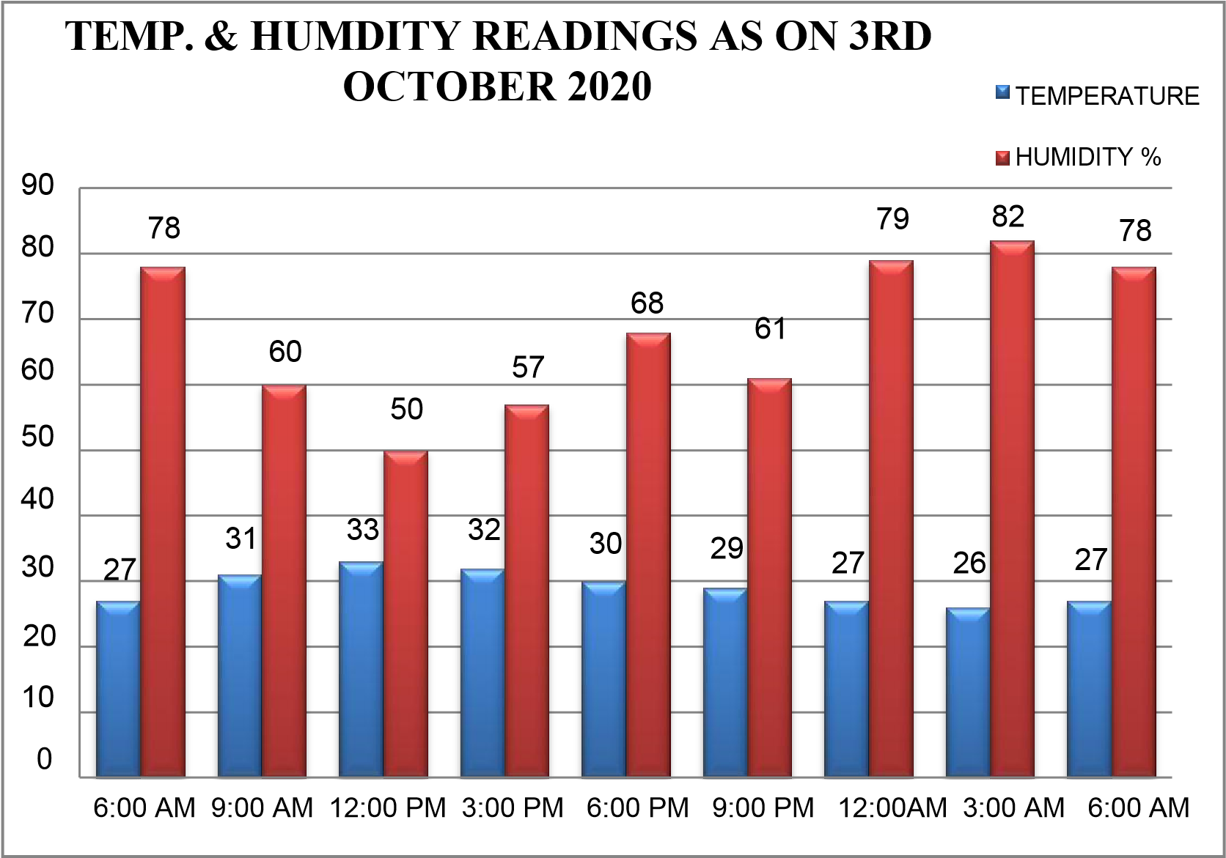

Figure 4.1.2: Temperature and humidity on 3rd october

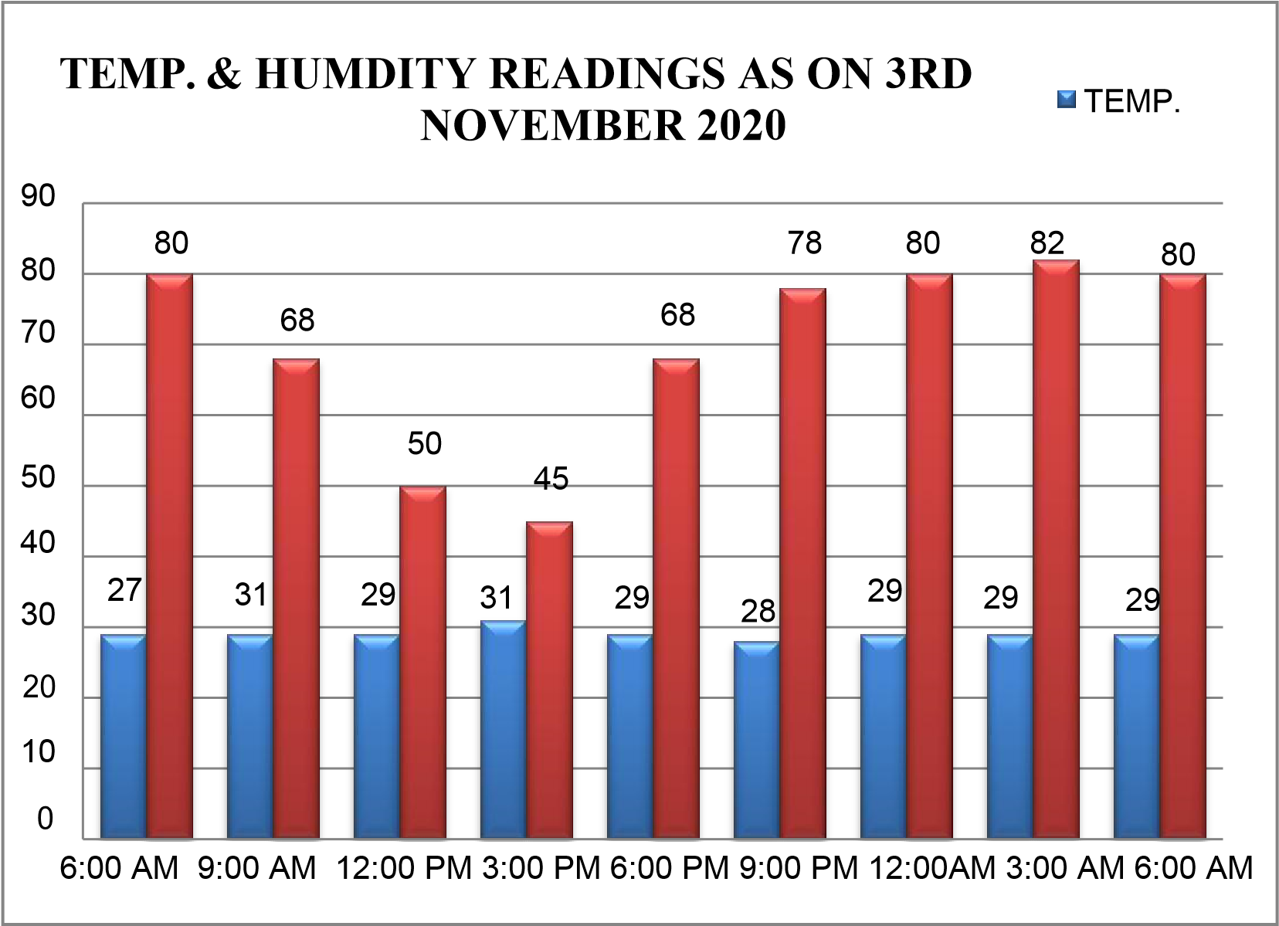

Figure 4.1.3: Temperature and humidity on 3rd November

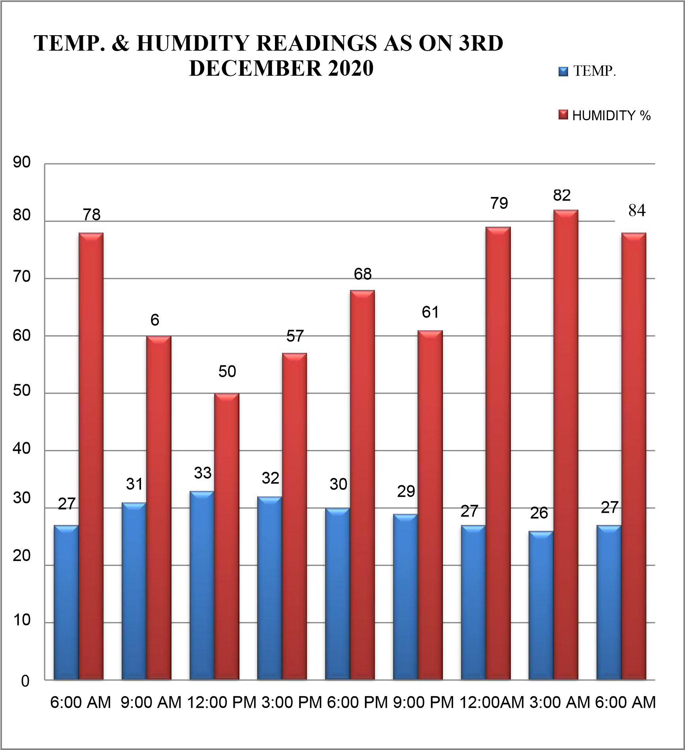

Figure 4.1.4: Temperature and humidity on 3rd December

By analyzing the temperature and humidity condition we concluded that the maximum humidity condition are attained after 8 pm to morning 7 am and temperature of air is also low during this period of time, due to which it is easy to attain dew point temperature and thus it is easy to condense water from air.

## CHAPTER 5

## DESIGN AND COMPONENTS

### 5.1 DESIGN OF THE PROJECT 3-Dimensional views

The 3-dimensional view of the model is as shown in the below figure

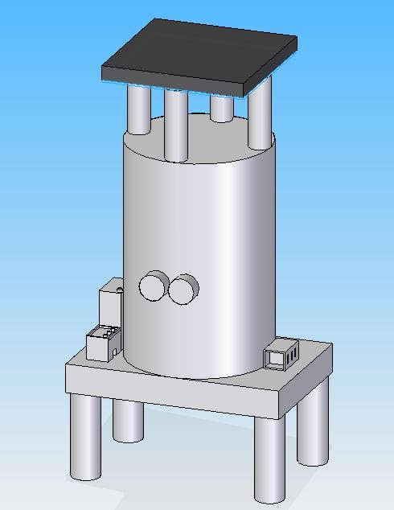

Solar panel

DC Fans

SMPS

Table/Stand

Battery

Charge controller

Figure 5.1.1: 3-dimensional view of assembly of the water extractor

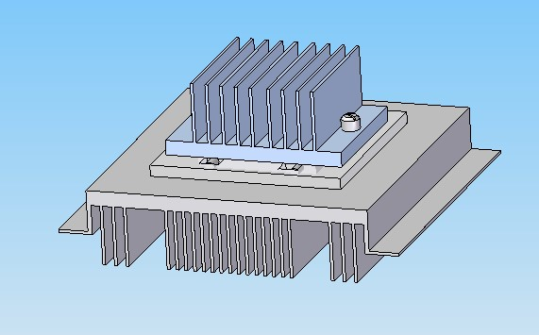

Figure 5.1.2: 3-dimensional view of peltier with heat sink

### 2-dimensional view of the assembly

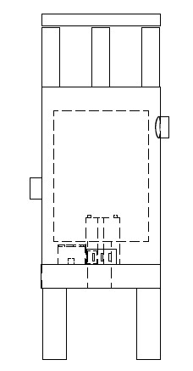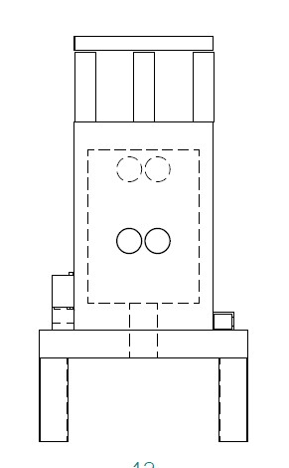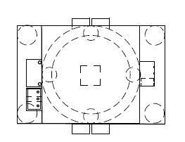

### Figure 5.1.3: 2-dimensional view of water extractor

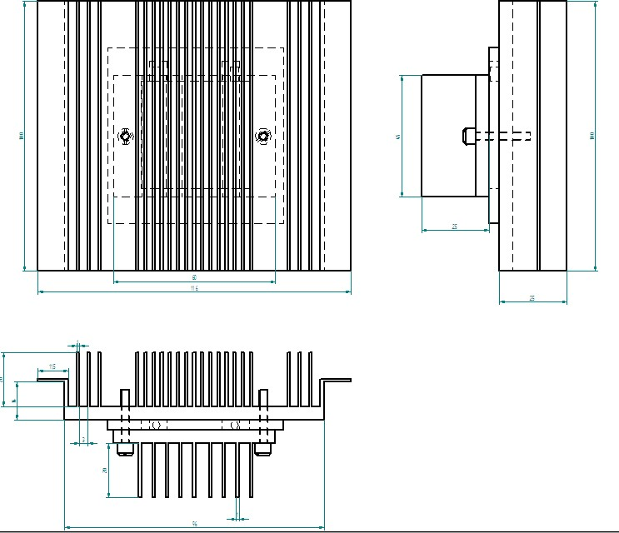

**Figure 5.1.4: 2-dimensional view of peltier module with heat sink**

### 5.2 DESCRIPTION OF INDIVIDUAL COMPONENTS

The water extractor consists of one solar panels, rechargeable batteries, one pulse width modulation (PWM) charge controller, two thermoelectric cooler, two dc fan and two heat sink. There will also be a backup system. The schematic diagram of the water extractor is shown in Figure 5.2.

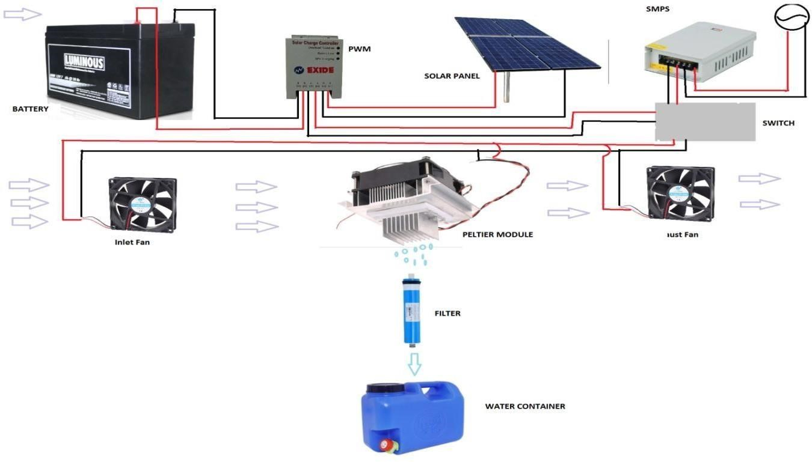

Figure 5.2 Schematic diagram of the water extractor

**5.2.1 SOLAR PHOTOVOLTAIC PANELS:**

In the period of industrialization, practicing environmental safety with sun based is the best arrangement. Sunlight based boards have been utilized worldwide and it is easy to store and generally safe to use in business purposes. Sunlight based photovoltaic boards are being utilized worldwide for creating power. The innovation of retaining sun's beam to energy has included numerous parts of utilizing the sun based as sustainable power source. In our system we have used one 5 watt 21V Poly crystalline solar panels. Its rated short circuit current is 0.5A. A single unit of solar panel is presented in Figure 5.2.1

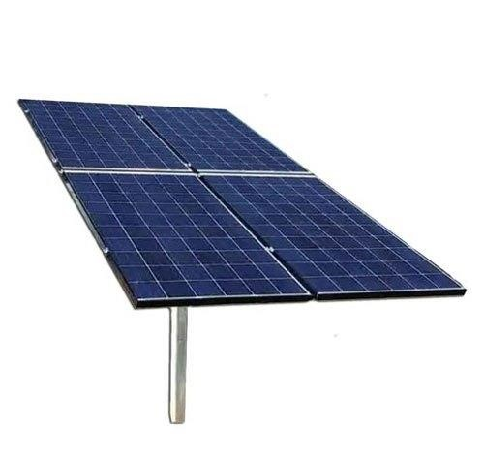

Figure: 5.2.1: Solar panel

**5.2.2 CHARGE CONTROLLER (PWM):**

Solar Charge Controllers provide a low-cost and excellent solution to regulating the harvested solar energy from the solar panels into the batteries and into the range required for the system. The charge controller having Pulse Width Modulation (PWM) strategy of 12V and 6A rated has been utilized as a part of our framework from Electro sun powered organization to run the 12V DC AWG. PWM charge controllers pull the sun based voltage to the essential voltage required for the load. Ideal execution is accomplished when sunlight based board output voltage is around 20% above battery full charge voltage. The charge controller is appeared in Fig. 5.2.2

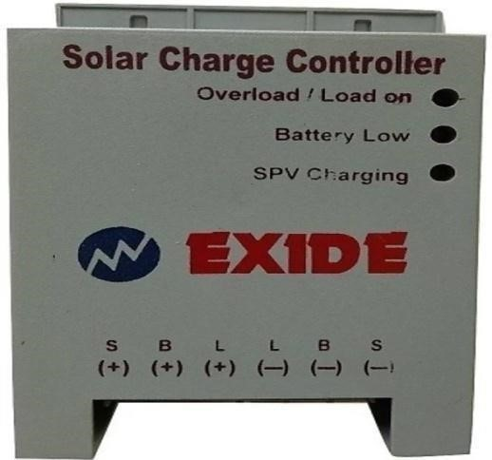

Fig.5.2.2 Charge controller

**5.2.3 BATTERY:**

Sunlight is not always same in our country due to cloud, rain and night time. For that reason, in the system, we have used batteries as back up when there is not enough sunlight. The rating of battery is 12 V and 20Ah. One 12V battery has been connected with the solar panel and AWG system. The dimension of the battery is 16.5 X 17.5 X

12.6 cm. The battery used for the proposed system is shown in Figure 5.2.3



Figure 5.2.3: 12v battery

**5.2.4 HEAT SINK:**

Basically heat sink is a hardware component that is attached above microprocessor or raspberry pie to keep it cool. It consist a dc fan and aluminum component to reduce heat from microprocessor or raspberry.

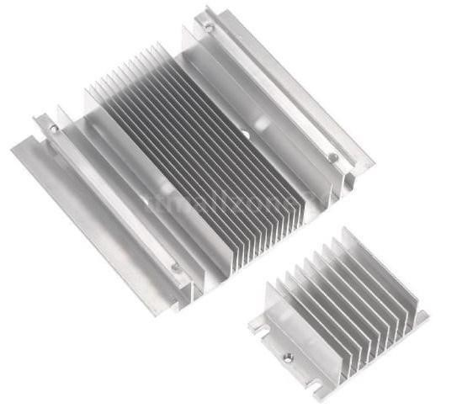

Figure 5.2.4: Heat sink

For our project heat sink is a major part. We have attached one large heat sink at the hot side of Peltier device. Using a heat sink at the hot side of Peltier plate is must because it reduces the heat and the heat is extracted by a DC fan. If a heat sink is not attached at the hot side of a Peltier device, the device will burn within 5 seconds after powering up. We have also attached a small aluminum heat sink at the cold side of Peltier device. That’s how it helps the humid air to condense. The dimension of the large heat sink is 12.5*5.5*2 cm and the small one is 6*4.5*3.8*2.1 cm. The heat sink used for the proposed system is shown in Figure 5.2.4

**5.2.5 BRUSHLESS DC FAN:**

Two 12v 0.16 A dc fan has been used in our project. We have attached one fan along with heat sink to extract heat. Another fan is used to pass external humid air to the system. The best thing is these fans consume very low current. The dc fan used for the proposed system is shown in Figure 5.2.5



Figure 5.2.5: Brushless DC Fan

**5.2.6 PELTIER:**

40x40 mm thermoelectric cooler (TEC-12706) has been used in your project. This device is also known as peltier plate. These coolers create a temperature differential on each side. One side gets hot and the other side gets cool.

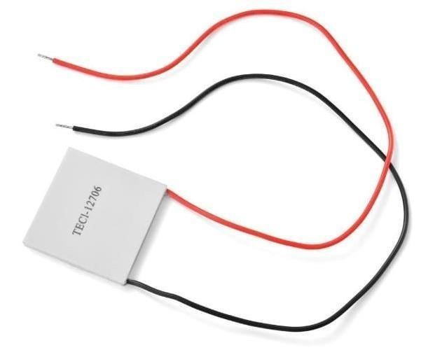

Figure 5.2.6: Peltier module

The Specification of TEC-12704 is given below- Dimensions (mm):40*40*3.8

Color: White

Maximum Power consumption: 60W

Maximum Voltage: 15V

Maximum Current Rating: 4A

Maximum allowable temperature: 66°C

The peltier used for the proposed system is shown in Figure 5.2.6.

**5.2.7 SWITCHED MODE POWER SUPPLY (SMPS)**

We have used an SMPS unit as auxillary power source. Its main function is to convert input AC 220V to output DC 12V.the specification of SMPS is given below:

Input voltage: 180-260 V AC

Output voltage: 12v DC

Current Range: 0 – 10 Amps

Voltage adj. range: 11.4 – 13.2 V

Voltage tolerance: ±2.0%

Line regulation: ±1.0%



Figure: 5.2.7 Switched mode power supply (smps)

## CHAPTER 6

**ADVANTAGES, DISADVANTAGES & APPLICATION**

### 6.1 ADVANTAGES

* Environment friendly: Traditional refrigeration system can't be manufactured without utilizing chlorofluorocarbons or different chemicals that might be destructive to our environment. Thermoelectric gadgets don't utilize or create gasses of any sort.
* Precise temperature control: - With a suitable temperature control circuit, thermoelectric module can control temperatures to superior to +/ - 0.1˚C.
* Capacity to cool underneath ambient: - Unlike a general heat sink whose temperature fundamentally should increase in respect with surrounding; a thermoelectric framework appended to that same heat sink can lessen the temperature beneath the ambient temperature.
* Using in Extreme condition: It can be utilized as a part of situations that are littler or more extreme than ordinary refrigeration.
* Long life span & reliability: Thermoelectric modules show high dependability because of their solid state development. Has a long life, MTBF surpassing just about 100,000 hours
* Controllable by means of changing the input voltage/current effectively.
* Low power consumption: Draw similarly low current than a compressor based refrigeration framework. Thermoelectric coolers can operate directly from a DC power source.
* Soundless Operation: - Unlike like a general mechanical refrigeration framework, thermoelectric modules produce purposes no electric commotion and can be utilized as a part of conjunction with touchy electronic sensors. They are additionally acoustically quiet.

**6.2 DISADVANTAGES:**

* The major disadvantage of the Peltier effect is that, it is inefficient.
* The flowing current itself tends to generate a significant amount of heat, which gets added to the overall heat dissipation.
* In large applications, this results in an excessive amount of heat, which needs to be taken care of.

**6.3 APPLICATIONS:**

* There are hardly any chances to refuse that this device is portable for its simple design and endurance capability.
* So, the Atmospheric Water Generator is the device which can be implemented for extreme situation, to use during flood, in desert areas, and in rural areas.
* It has great advantages as it works like a renewable source of atmosphere water and doesn’t need a heavy power source.
* Many company like ‘Watermaker India ltd’, ‘Aerowater’, etc have already this type of device for domestic purpose.
* It can be implemented for Industrial development where the water is a matter of crisis.

## REFERENCES

1. Mrs.N.Deepa,Gokulprasad.M, Muhammad Mishal, Mohamed Asharutheen.A, (Assistant professors, Dept. of Electronics and Instrumentation Engineering SRM

Institute of Science and Technology ,Chennai, India), „Device For Extracting Water from Air‟, Volume 118 No. 20 2018, 4451-4455 , JUNE 2015

1. Kiran Pawar, V. S. Shinde, (Department of Mechanical Engineering, Savitribai Phule

Pune University Pune, India), „Performance Evaluation of Solar Powered Peltier Condenser to Extract Water from Ambient Air‟, 2 Page 607-612, 2015, ISSN 2395- 1621, NOV 2015

1. Ajinkya Taksale, (Dept. of Mechanical Engineering, NBN Sinhgad School of Engineering, Pune, India).March 2016
2. Paul M. Cabacungan, Jromed C. Cheng, Daphne Loren C. Landoy, Angeli C. Silang, Rodolfo A. Buenafe, Gregory L. Tangonan, Nathaniel J.C. Libatique, Tristan H. Calasanz (Ateneo Innovation Center, Ateneo de Manila University, Loyola Height, Q.C.), Conference Paper, March 2009.
3. Atul Ekad1, Tejas Pawar, Nitish Yeole, Ajinkya Taksale, Aanand Gajjar BE-Mech.

„Solar Powered Atmospheric Water Generator and overview on AWG technologies‟,

Dept. of Mechanical Engineering, NBN Sinhgad School of Engineering, Pune, India,Vol. 7, Issue 1, January 2018.

1. Hayder Sami Saleh Al-Madhhachi,‟ Solar Powered Thermoelectric
2. Distillation System „, Institute of Energy School of Engineering Cardiff University, vol , issue1, December 2017
3. Robert A. Taylor, Thesis on „Comprehensive Optimization for Thermoelectric Refrigeration Devices‟, University of Missouri – Columbia, December 2005
4. Rohan Gupta, Jogesh Gupta, Ajay Gupta and Uday Mahadik, „Water Through Air using Peltier Elements‟, International Journal of Science Technology & Engineering, Volume 2, Issue 09, March 2016
5. Khaled Teffah, Youtong Zhang and Xiao-long Mou , „Modeling and Experimentation of New Thermoelectric Cooler–Thermoelectric Generator Module‟, 7 March 2018